Research Project 6

1. Take the following surveys:
   1. WILL BE POSTED LATER.
2. Be sure to enter your M number to get credit!
3. If your survey is listed, you must share the data with the group (so I can give people credit for completing).
   1. You can turn this assignment in “late” – by Monday 10/7.
   2. You must complete the other surveys by Friday 10/4.

Share your data:

1. In statcrunch, under my surveys – click on Analyze to see your data.

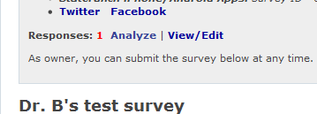

1. This will open a new window with the dataset.

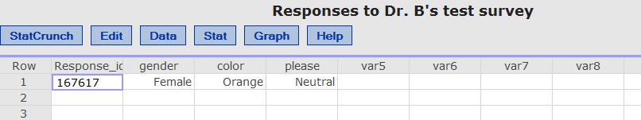

1. Go to Data > Save Data.
2. Hit save.
3. You’ll get this message:

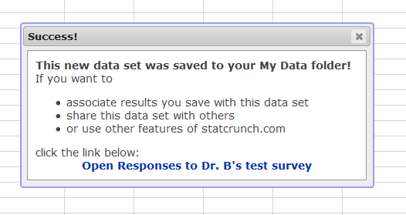

1. In the regular statcrunch window (not the data), go to your group. Click “my groups”.
2. On the left hand side, click “data sets”.

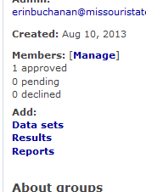

1. Pick your saved dataset to share.

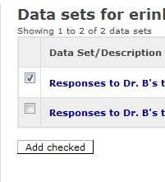

1. Now you should see the dataset in the regular group page.

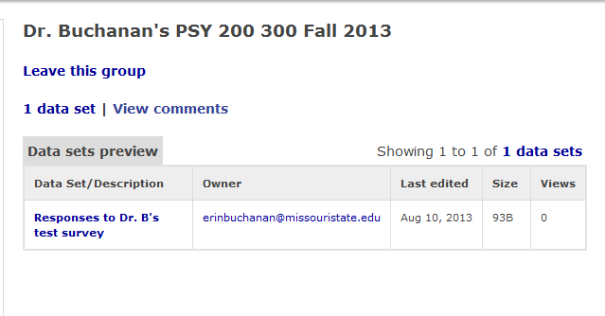

1. Only one person from each group should share data.